**SHOOTING SUBSYSTEM**

There are two issues that stand out in this part of the project. The first one is to determine the mechanical design of the shooting part and the other to choose the motor to be used for this shooting. When determining the mechanical design for the shooting system, it was necessary to select the one that would provide the best shooting experience. For this reason, we tried to develop different solutions by making some 3D drawings. The program which is called “Rhinoceros” is used for 3d modeling of the shooting subsystem and “Keyshot” is used to get the end product image of the system.

For shooting mechanical design part, our main solution axonometric perspective can bee sen in Figure X.

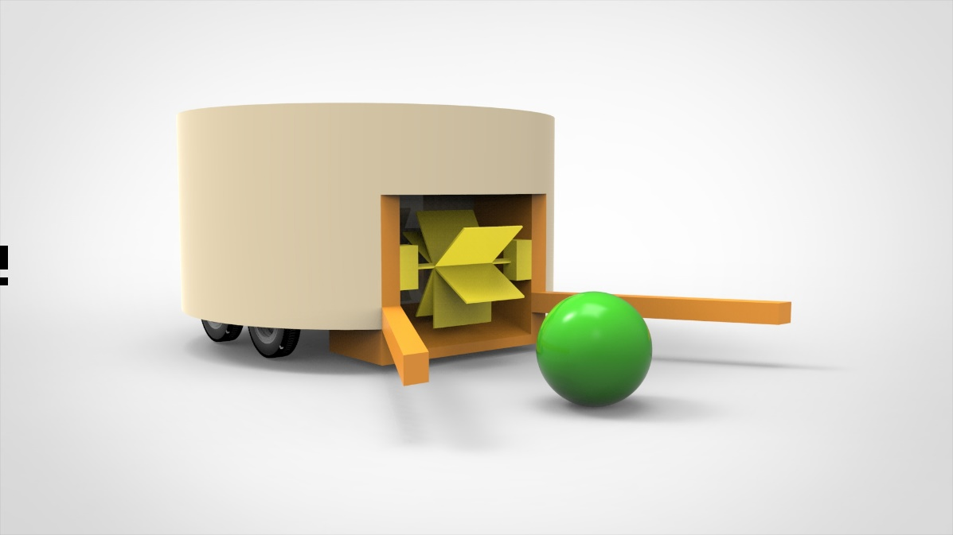

Figure 1: First Shooting Subsytem Design Axonometric View

According to our experiences, there should be two angular sticks that are parallel to ground for holding the ball closer to rotational shooting part.

However, the size of the goal in our project will be determined by the size of the widest part of the robot, the decision to use these sticks will be made after the demo matches. Therefore, it was decided not to use the sticks in backup design while keeping the sticks in the main solution.

In the Figure X, the orange ones are represent these sticks. The radius of the ball is 4 cm and it gives reference for the rest of the model. The length of the sticks are 6 cm and the radius of larger cylindrical part is around 20 cm. The yellow parts represent the rotational shooting system.

For better understanding, this design can be examined in two different aspects in Figure X + 1 and Figure X + 2.

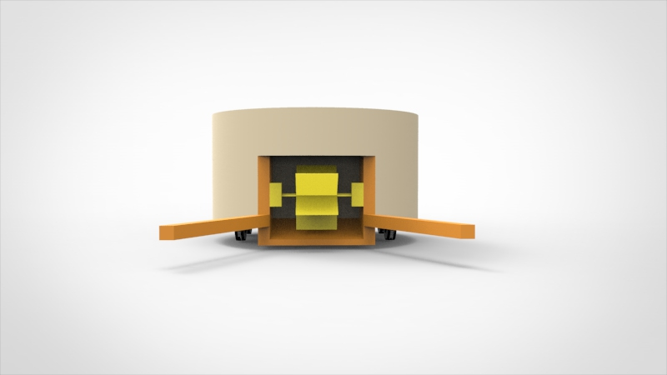

Figure 2: First Shooting Subsytem Design Front View

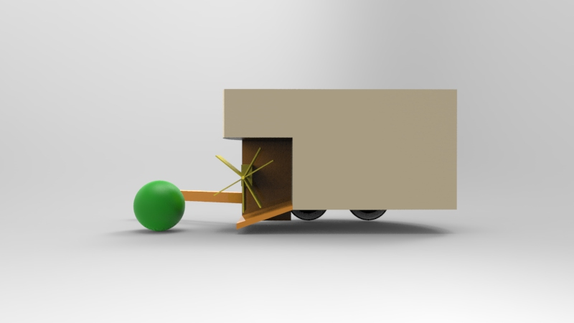

Figure 3: First Shooting Subsytem Design Side View

For shooting mechanical design part, our backup solution axonometric perspective can bee sen in Figure X+3.^

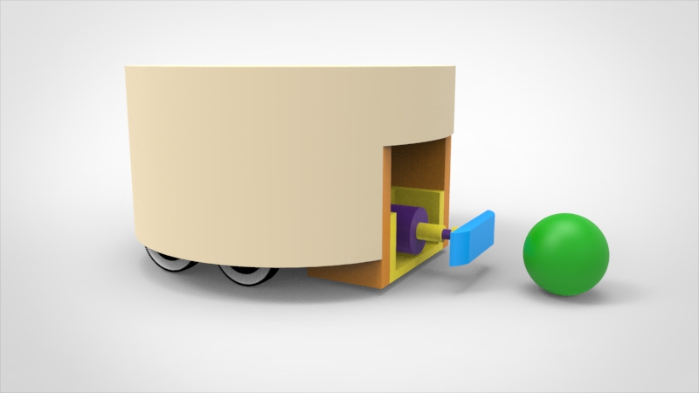

Figure 4: Second Shooting Subsytem Design Axonometric View

In this design, the part indicated by the blue part comes out of the robot and hits the ball. It is compressed by the spring system inside and then it is released so that the ball is hit.

For this application, it was decided to construct a spring actuated shooting device.

To wind the spring up, a spindle with nut is used. The nut presses against the spring which is thereby compressed. A lock and release mechanism holds the plunger in place and releases it when needed.

The time needed for the winding of the spring is the most important problem for this design. Therefore, the determination of the spring type and maximum force of the motor will be the most important stages.

For better understanding, this design can be examined in two different aspects in Figure X + 4 and Figure X + 5.

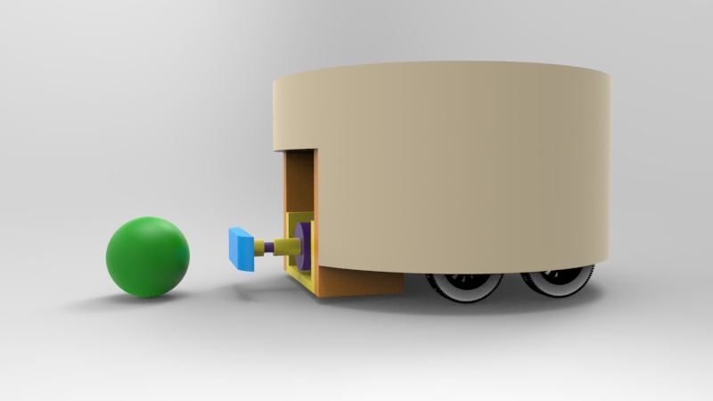

Figure 5: Second Shooting Subsytem Design Side View

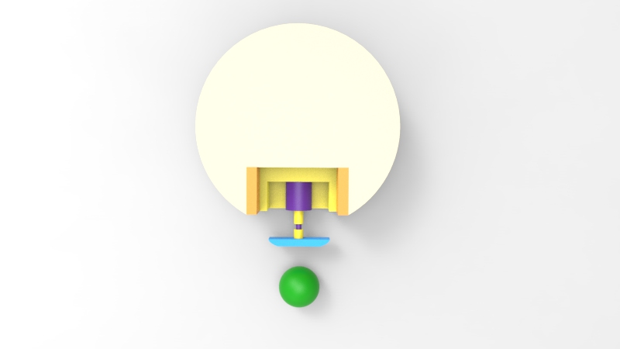

Figure 6: Second Shooting Subsytem Design Top View

For choosing the motor of shooting system is the second topic for shooting system. There can be 3 motor types to use in shootng part and main solution is usage of DC motors for that.

DC motors are the most widely used engines in robotics. Also, the DC motors have magnets instead of the coils in the stepper motors. The DC motors are available in a variety of versions with or without gearbox, which have different operating voltages and rpm values. Speed control of DC motors can be done with pwm. DC motors are cheap, small and effective. Also, the wide variety of sizes, shapes and power is another reason for the frequent use of DC motors. For these reasons, they are ideal motorss for using as a shooting part motor.

Also the usage of Step Motor is our second solution. Stepper motors are electric motors which are surrounded by a magnet or a metal rotor and a coil that creates an inductance of voltage by creating an electromagnetic field effect. They are also suitable for sensitive applications such as robot arm applications and laboratory robots. However, areas of use are narrowed due to the heavy weigh, high current draws, low torque and difficulty in assembling in robotics. Hence, this type of motor will remain as our backup plan.

The usage of Servo Motor is our third solution for shooting system. Servo motors are very used in robot operations, especially since they are very easy to control and do not require any control circuitry. Although servo motors have advantageous features such as easy control and installation, compatibility with robot projects and having their own gearbox; they are not as popular as dc motors due to their costly, low torque and ineffective speed controls.

## Level Risks Assessment

There are few risks of the shooting system.

* This subsystem heats a lot which can create a risk for other parts of the system.
* The command to be given from the controller can be corrupted.

## Error Sources

Some internal and external sources can cause an error at this subsystem. The possible error sources are as follows:

* Environmental temperature conditions can be a source of error. To eliminate this effect heat sink or fan can be used.
* Overflow can be an error caused by increasing the current coming to the system. To eliminate this a voltage comparator can be used so that we should be sure that we are not feeding the systems a voltage higher than 12V.
* Wrong command can be the problem for shooting system. To eliminate this, we can use more accurate signals.